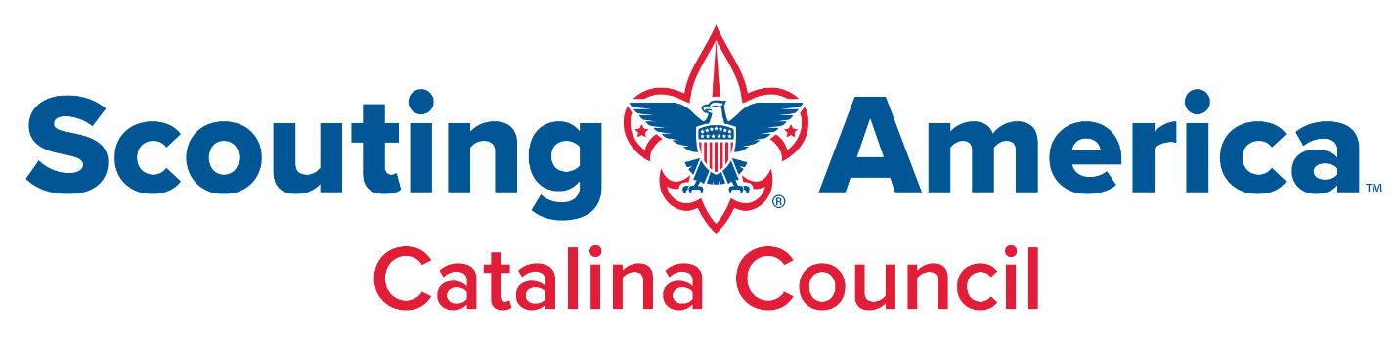
Scholarship Criteria
Catalina Council's Scholarship Program aims to provide financial assistance to youth from economically disadvantaged backgrounds. The program uses a sliding scale based on the recipient’s household income, referencing 200%, 175%, 150%, 125%, and 100% of the federal poverty level.
Applicants must provide proof of annual household income and monthly household expenses.
Below are the eligibility criteria and income limits based on family size:
Eligibility Criteria:
- The applicant's household income must fall within the predetermined percentage brackets of the federal poverty level, as listed below.
- The applicant must provide documented proof of their annual income and monthly expenses.
Income Allowances based on Family Size (Annual Income):
(Note: The figures below are illustrative examples and may be subject to change based on current federal poverty guidelines)
Family Size | 100% FPL | 125% FPL | 150% FPL | 175% FPL | 200% FPL
1 | $15,060 | $18,825 | $22,590 | $26,355 | $30,120
2 | $20,440 | $25,550 | $30,660 | $35,770 | $40,880
3 | $25,820 | $32,275 | $38,730 | $45,185 | $51.640
4 | $31,200 | $39,000 | $46,800 | $54,600 | $62,400
5 | $36,580 | $45,725 | $54,870 | $64,015 | $73,160
6 | $41,960 | $52,450 | $62,940 | $73,430 | $83,920
7 | $47,340 | $59,175 | $71,010 | $82,845 | $94,680
8 | $52,720 | $65,900 | $79,080 | $92,260 | $105,440
For families/households with more than 8 persons, add $5,380 for each additional person.
Note that 100% of FPL represents the highest point of the FPL bracket.

Financial Needs Criteria for Scholarship Determination:
To ensure accurate assessment and fair distribution of financial assistance through the Scholarship program, we require the following criteria to determine an applicant's financial needs:
- Proof of Income for the Last 30 Days:
  - Applicants must provide documented proof of income for the past 30 days. This can include recent pay stubs, income statements, or any other official documentation that accurately reflects the applicant's current financial situation.
- Proof of Living Expenses for the Last 30 Days:
  - Applicants must provide documented proof of their living expenses for the past 30 days. This should include essential expenses such as mortgage/rent payments, utilities (e.g., electricity, water, gas), and any other necessary living costs.
- Verification of Mortgage/Rent Payments:
  - Applicants must submit documentation that verifies their mortgage or rent payments for the past 30 days. This can be in the form of rent receipts, lease agreements, or mortgage statements.
- Verification of Utilities Expenses:
  - Applicants must provide documentation that verifies their utility expenses for the past 30 days. This can include utility bills, receipts, or any official documentation indicating the amount paid for utilities during the specified period.
By requiring proof of income and living expenses for the last 30 days, we aim to accurately assess an applicant's financial situation and determine their eligibility for financial assistance. This information will be treated with strict confidentiality and used solely for the purpose of evaluating financial needs.
Please ensure all submitted documents are clear, legible, and reflect the most recent 30-day period. Incomplete or insufficient documentation may delay the evaluation process or result in the application being deemed ineligible.
If you have any questions or need further clarification regarding the documentation required, please do not hesitate to contact our scholarship program coordinator at [kathleen.robinson@scouting.org]. We are here to assist you throughout the application process.
Thank you for your cooperation and interest in the scholarship program.

